IdeationPhase

Brainstorm&IdeaPrioritizationTemplate

|  |  |
| --- | --- |
| Date | 26 June2025 |
| TeamID | LTVIP2025TMID33776 |
| ProjectName | Pattern sense:ClassifyingFabricPatternsusingDeep Learning |
| MaximumMarks | 4Marks |

**Brainstorm&IdeaPrioritizationTemplate:**

**Step-1:TeamGathering,CollaborationandSelecttheProblemStatement** Before you collaborate

10minutesto prepare

1hourtocollaborate

2–6 people recommended

TeamGathering:

Gathertherequiredparticipantsforthesessionandensurethey’vereceived information or problem context.

SettheGoal:

Thegoalistosolvetheproblem:

“How can we effectively classify various fabricpatternsusingdeeplearningtoaidin textile industry automation?”

DefineProblemStatement:

“Fabric classification is a manual and error-prone task. How might we automate the recognition of fabric patterns (e.g., striped, checked, floral) using deep learning to increase efficiency in textile sorting?”

KeyRulesof Brainstorming:

* Stayontopic
* Goforvolume
* Encouragewildideas
* Build on ideas
* Be visual if possible
* Listentoothers

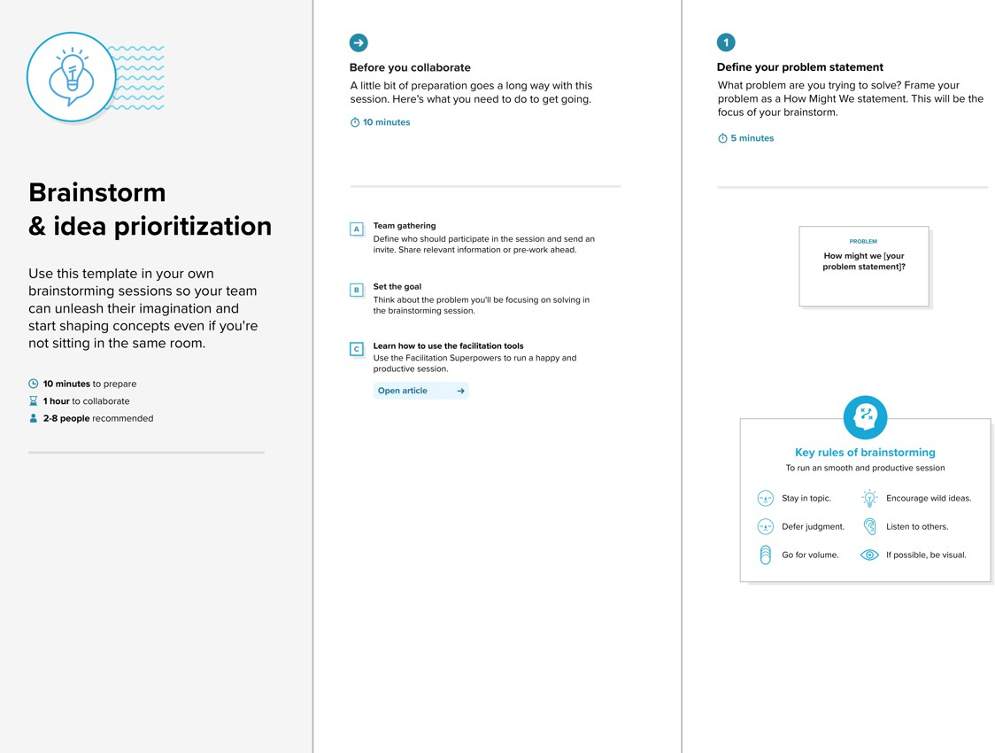

**Step-2:Brainstorm,IdeaListingandGrouping**

Brainstorm(20mins):

Writedownasmanyideasthatcometomindthataddressyourproblemstatement:

* UseaCNN-basedimageclassifiertrainedonlabeledfabricpatterns.
* Dataaugmentationforunderrepresentedpatterns(e.g.,abstractdesigns).
* Useattention-basedmodelsfortexture-focusedrecognition.
* Applytransferlearningwithpre-trainedResNetorEfficientNet.
* Buildamobileappforreal-timefabricidentificationusingcamerainput.

GroupIdeas(30mins):

Groupsimilarideastoformclusterssuchas:

* DataCollection& Preprocessing
* Model Architecture
* UserInterfaceIntegration
* IndustrialDeploymentFeasibility

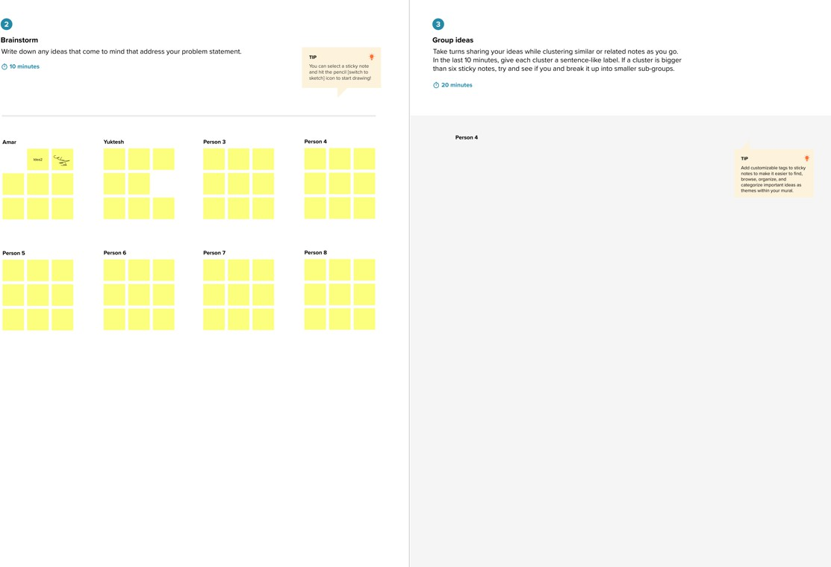**Step-3:IdeaPrioritization**

Prioritize(30mins):

Place your ideas on a 2x2 grid to determine which ones are important andfeasibletofocus on.

Axis | Description

------------|------------------------------------------

Importance|Howwelltheideasolvesthemainproblem Feasibility | Can we realistically implement this idea

Examplegrid placement:

* HighImportance,HighFeasibility:CNNwithtransferlearning
* HighImportance,LowFeasibility:Real-timeedgedevice deployment
* MediumImportance,MediumFeasibility:Mobileappinterface

